# HW 3 – Intelligent Control Theory

In this exercise we were tasked to compare the fuzzy logic controllers of Type 1 and Type 2. To accomplish this I expanded the expanded the Control class to take a type parameter to toggle between both system types and implement a fuzzy rule set for the controller. By running a simulation of both controllers we can compare a type 1 and type 2 system:

## Comparing the Types

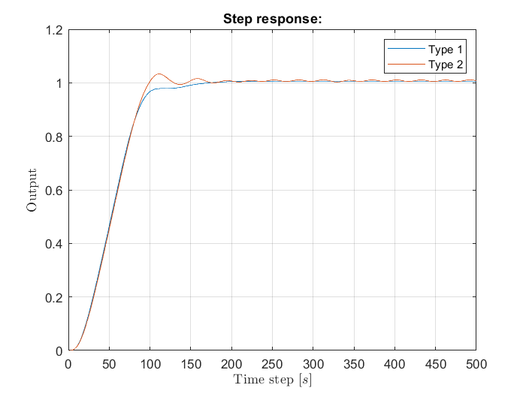

Both systems have a similar rise time, but the type 2 system seems to oscillate and overshoot more than the type 1 system. This might be because it takes more of the fuzzy rules into account which leads to a less sure response.

## Adding noise

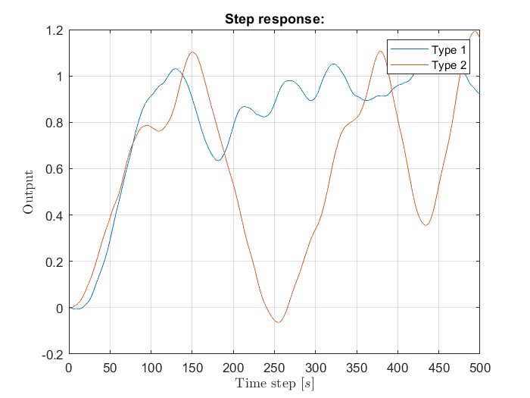To compare the performance of the controllers in a noisy environment we had to add noise to the plant. In order to do so white noise of +/-5*10-5 and +/-5*10-4 was added to y[0] while calculating the next system state.

### Results

Noise of more than +/-5*10-4 lead to a highly unstable system with the type 2 controller performing far worse than type 1.

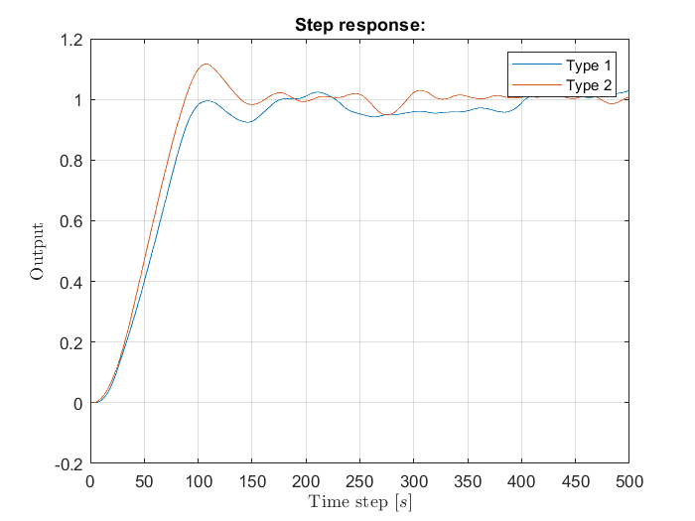

After adding +/- 1*10-4 random noise clear differences between the contoller types could be observed, as the type 2 controller had a more adaptive response and could keep the system closer to the target value

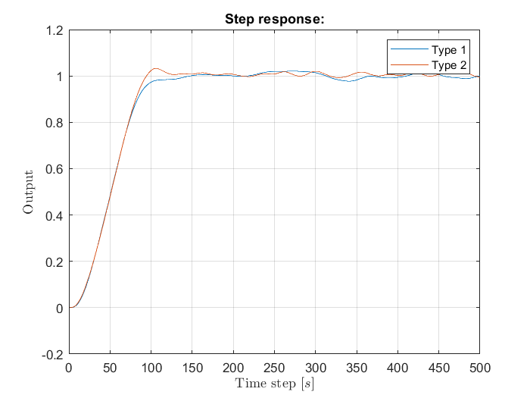

The same could be observed with 5*10-5 of noise. But here the oscillations of the type 2 systems surfaced again.